INFORMATION FOR PARTICIPANTS OF THE MEETING WITH UN PROCUREMENT OFFICERS 2026
Vienna, June 9th and 10th, 2026
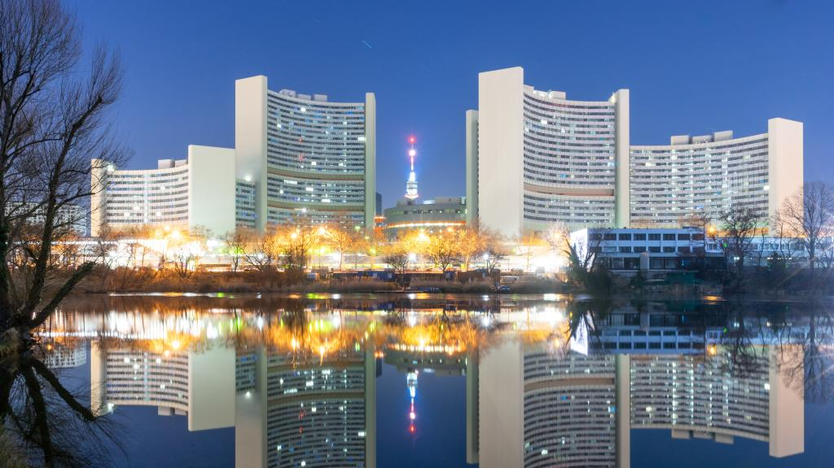





Venue: Embassy of the Czech Republic in Vienna
Penzinger Str. 11–13 | 1140 Vienna
Parking Options
General information about parking in Vienna can be found HERE.
Almost the entire city of Vienna is designated as a short-term parking zone with the following rules:
- Short-term parking applies Monday to Friday from 9:00 AM to 10:00 PM (except public holidays).
- Unless otherwise stated, the maximum parking duration is two hours.
Parking tickets are available in paper form or via the Handyparken mobile app or the international EasyPark app (which charges a higher service fee).
Paper parking tickets can be purchased at tobacco shops, kiosks, cigarette vending machines, gas stations, post offices, Wiener Linien sales points, ticket offices, and ticket machines.
The price for 30 minutes is €1.70. In short-term parking zones, a parking ticket is required from the very first minute of parking, including brief stops such as unloading luggage. Free 15-minute parking tickets are also available.
Please also observe local traffic signs and restrictions (some restrictions apply in both directions).

Nearby Parking Garages:
P1: APCOA Parking, Schönbrunner Schloßstraße, 1130 Vienna (from €4.20/hour)
https://www.apcoa.at/parken/wien/schoenbrunn-wien-apcoa-1/
P2: Schlossallee Schönbrunn Garage, Linzer Str. 3a, 1140 Vienna (from €3.20/hour)
https://www.bestinparking.com/de/at/garage/garage-schlossallee-schoenbrunn
P3: Park + Ride Hütteldorf (€4.10 for 0–24 hours)
https://www.bestinparking.com/en/at/garage/park-ride-hutteldorf
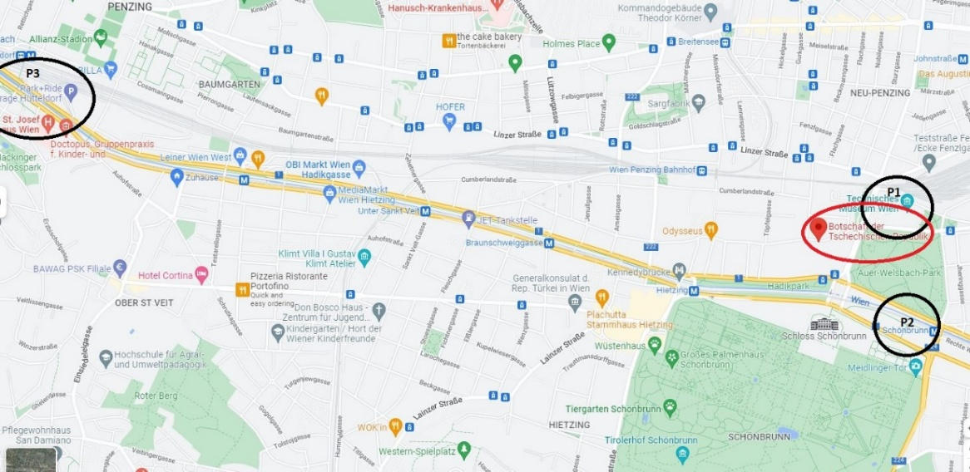

Event Program
During both days, there will be presentations by agency representatives about cooperation opportunities, as well as panel discussions. At the same time, B2B meetings between companies and agency procurement officers will take place.
The detailed program will be specified.

Accommodation

Close to the venue:

HB1 Design & Budget Hotel Wien Schönbrunn (from €90/night)
https://www.hb1.at/hotel-schoenbrunn/

DoubleTree by Hilton Vienna Schönbrunn (from €119/night)
https://www.hilton.com/en/hotels/viescdi-doubletree-vienna-schonbrunn

Hietzing Area (Approx. 10-Minute Walk)

Parkhotel Schönbrunn (from €100/night)
https://www.austria-trend.at/de/hotels/parkhotel-schoenbrunn

Hotel Maximilian (from €108/night)
https://www.austria-trend.at/de/hotels/maximilian

Hotel Viktoria (from €106/night)
https://www.hotelviktoria.co.at/

About 15 Minutes by Tram – Hotels Near Westbahnhof and Mariahilferstraße

IntercityHotel Wien (from €83/night)
https://hrewards.com/de/intercityhotel-wien

Motel One Wien-Westbahnhof (from €112/night)
https://www.motel-one.com/de/hotels/wien/

JO&JOE Wien (from €54/night)
https://www.joandjoe.com/vienna/de/

Preparation for Meetings

Due to the participation of at least 120 companies, it is not possible to place banners, promotional materials, or other items within the premises. Please therefore prepare these materials for handover during individual meetings.

We recommend bringing:

a brief company profile,

a presentation on a laptop or a printed one-pager,

and possibly a short catalog in English.

Relevant references and case studies are particularly important, especially those emphasizing experience with international projects, public procurement, and institutions of a similar type.

If you have any questions, do not hesitate to contact us.

