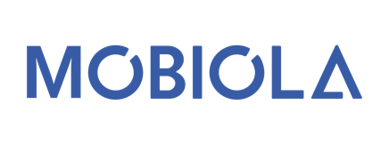

Dear business partners,

we would like to introduce you to MOBIOLA WORLDWIDE s.r.o, a Czech manufacturer and supplier of classic mobile phones and electronic accessories. Our company is located in Czech republic where we develop and design our products.
We follow the development of the Bulgarian market with great interest and believe that our products could be of benefit to your company and to your customers.

As you can see in enclosure we specialize in the production and delivery of:
• mobile phone MOBIOLA
• rechargeable batteries MOBIOLA
• phone accessories and spare parts for MOBIOLA phones

Our products are characterized by high quality, durability and reliability. We emphasize an individual approach to needs and are able to meet your specific requirements. Also you can find fully translated software and manual in Bulgarian language.
We are pleased to present our offer to you having interest in longterm business cooperation with the Bulgarian profesional distributing or sales company.
In case of your interest we are ready introduce our products and business conditions to you.

With best regards,
MOBIOLA Team

Mr. Martin Lopušan
CEO & Sales Director
Contact Data:
Mobile: +421 903 821 311
Email: lopusan@mobiola.eu

