**Are you looking for a quality manufacturer of complete lifts and other lift components?**

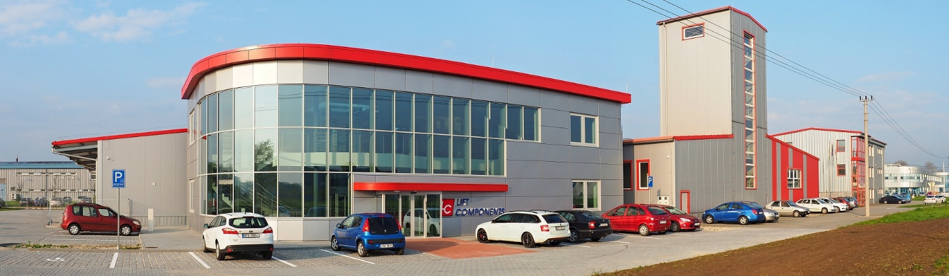

Dear Sir,

We would like to approach you with an offer of our lifts.

Lift Components s.r.o. (LC Lifts) is a **Czech manufacturer of complete lifts** and platforms with over 20 years of experience. We also provide new feature development and testing.

LC Lifts operate at B2B market. We produce whole lifts and sell them to wide range of partners, who provide subsequent installation and maintenance. **Lift as a building kit for easy installation.**

* **Lifts are completely** **manufactured and tested** in our production plant in Czech Republic
* **We are a stable company -** we have produced lifts in the Czech Republic for more than 20 years
* **100% Czech capital** - we cover all investments from our own resources
* **Already more than 5000 lifts** and many other components in the Czech Republic and Slovakia.
* **Czech stability award certificate "AAA Platinum Excellent"** - our company is one of the most economically stable companies in the Czech Republic and meets the strictest economic criteria.
* **Our lifts are remotely monitored** = cost reduction for service and maintenance (you can watch your lift in an online application and solve some issues remotely, without personal visit)

**In enclosure you can find:**

1. **Main catalogue Lifts with the brand LC** – information about our products
2. **Lift portfolio** – Parameter tables for all our standard lifts

**In our production plant in Karvina, we also have big showroom**, where you can see all our products (lift cabins, frames, machines, doors…) and you can also try ride in our lifts.

You are sincerely welcomed to visit our showroom and testing tower.

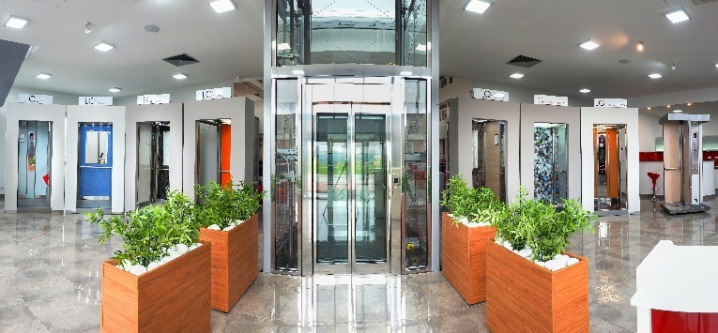

If you find it interesting, please contact our company for more information.

**Who will work for you**

Mr. Radomír Waliczek and Mr. Lukáš Kvapil from sales department and Mrs. Barbora Kotasová from financial department will handle all your questions, emails and phone calls.

**Please do not hesitate to contact us**

**Mr. Lukáš Kvapil (sales manager)**

Tel. +420 771 134 670

Email: [kalkulace@liftcomponents.cz](mailto:kalkulace@liftcomponents.cz)

**Mrs. Barbora Kotasová**

Tel. +420 773 757 149

Email: [barborakotasova@liftcomponents.cz](mailto:barborakotasova@liftcomponents.cz)